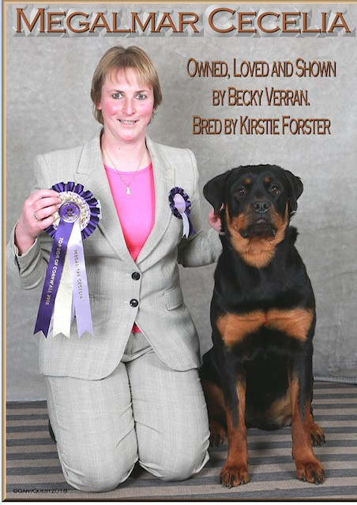

This little lady has done me proud with her showing to date. Following the sudden and unexpected loss of my dear Roxy – Dromnagus All Eyes On Me ShCM who did extremely well in the show ring, Indy had big boots to fill and is doing a very good job so far. Her show career started off well with her winning 5 Best in Shows, 3 Reserve Best in Shows and 4 Best Puppy in Shows at Fun shows throughout the summer from the age of 14 weeks to 6 months. Once she reached 6 months of age she continued her success:
- Crufts qualified at every Champ Show attended
- Qualified for Top Dog of Cornwall 2018
- Multiple Best Puppy in Breed and group placings at Open shows attended
Grateful thanks to Kirstie Forster – Megalmar for entrusting me with this special girl and thank you to Gary Quest for the photo. Rebecca Verran RIN

