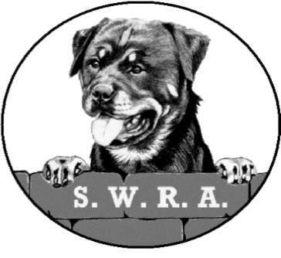
SOUTH WESTERN
ROTTWEILER ASSOCIATION

Membership Application
*Membership renewals are due 01st January each year.

Name: _______________________________________________________________

Address: _______________________________________________________________

_______________________________________________________________

_______________________________________________________________

Telephone: _______________________________________________________________

Email: _______________________________________________________________

- In the event of the SWRA supporting an Open show, the SWRA may pass on your address to that Canine Society. If you do not wish your details to be passed on, please tick here □
- I/We agree to my details being held on a database □
- I/We agree to abide by the Rules of the Association □

This is a Renewal □ This is a New Application □

Signed: _______________________________________________________________

* A Proposer and Seconder are required for NEW APPLICATIONS ONLY

Proposer’s Name: ______________________ Signature: ________________________

Seconder’s Name: ______________________ Signature: ________________________

Annual Subscription for 2019: Single/Joint £10.00 a year

Please complete the attached Standing Order Mandate and send it with this form to:
Nicola Marker, Trefor Cottage, Shute Lane, Pensilva, LISKEARD PL14 5QD.
If you would rather pay by Cheque, they should be made payable to “SWRA”.

